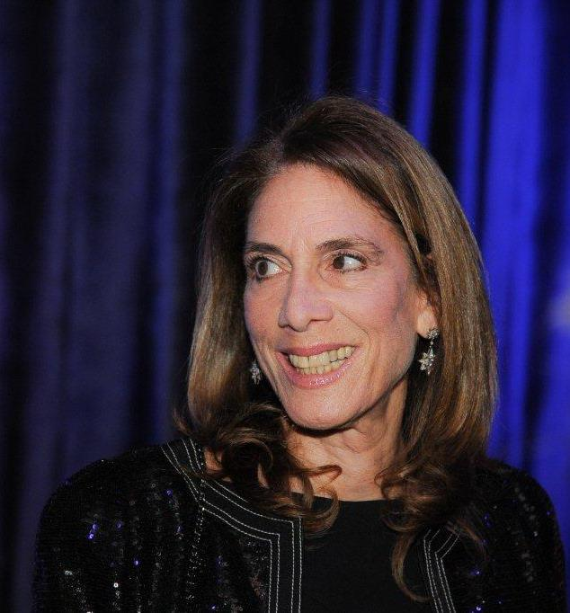

Irith Rappaport : VP financial and corporate ccommunication, Policy Ltd. : Over 25 years’ experience in international business development, management and operations, with seven years of intensive former Soviet Union involvement, including negotiations, project start up and management, budget and financial controls, contacts with financial institutions, government and labor relations, investor relations and communications. Ms. Rappaport has experience in setting up service and business operations abroad, including management and training activities, on behalf of foreign investors in cooperation with government enterprises and local institutions, amongst other places in Moscow and Tbilisi.

Since December 1998: VP Investors Relations and Corporate Communication and Business Development with Policy Ltd.- Business and Political Communication Management – Tel Aviv and International relations Division – responsible for Policy’s multi- national clients and the affiliation activities. Ms Rappaport is primarily responsible for multinational clients in the pharmaceutical and medical device industry, banking and finance sector, consumer and service companies, energy and industrial sector. During her years as strategic and crisis management consultant with Policy, Irith has accrued vast experience in media counseling and working with the international media.

Prior to joining Policy, she spent seven years in the CIS as Chief Operating Officer supervising projects in Moscow, St Petersburg, Uzbekistan and many other republics, represented foreign investors for IVOG oil exploration and production in Georgia. She also served as VP Operations for the Inter Maritime Group in Geneva, Switzerland and later as the group’s Project Development Manager. In this capacity, she was responsible for sensitive business negotiations, management of investors’ interest in joint ventures with government agencies and the establishment of overseas business operations.

Irith Rappaport acts as the deputy chairperson of the Rappaport Family Foundation. In recent years Ms Rappaport has managed projects on behalf of the Rappaport Family Foundation such as the construction of the Ruth Children Hospital at the Rambam Medical Campus in Haifa, was instrumental in establishing the various family prize awards in the arts, science and women outstanding achievements. She organizes and supervised special events on behalf of the foundation.

Born in Israel, raised in Geneva, Switzerland, graduated from New York University school of Journalism and Mass Communications, Ms. Rappaport sits on the Board of Governors of the Tel Aviv Museum of Art, as well as on the board of Directors of the Museum. Irith Rappaport is the President of the Friends of the Tel Aviv Museum of Art in Israel. Her other activities include: Member of the board of the Israel Philharmonic Orchestra, member of the Board of Governors of Shenkar Institute of Design and Technology and Member of the Board of Directors, active Chairperson of Biorap( the technological transfer commercial company of the Rappaport Institute of BioMedical Research) and deputy Chairperson of the Rappaport Research institute for biomedical sciences, by the Technion.

Ms Rappaport is also a founding member of the initiative “Committed to Give”, promoting Israeli Philanthropy, http://www.ctg.org.il.

